Strength-Based Practice Entry Points
What are some ways that, without even talking, a student in a school setting can communicate information about themselves, information that might be an entry point to engage with that student’s possible strengths?

- Fashion
- Smiling
- Never smiling (“I’m pissed, but I’m here!”)
- Eye contact
- Mature look in their eyes
- Social butterfly
- Keeping to oneself (“I’ll trust when I’m ready!”)
- Doing homework
- Friends clearly look up to them
- Good listener
- Respectful to the opposite sex
- Disrespectful to everyone (“I feel like I don’t belong!”)
- Coming on time

What are some surface-level ways a staff member in a school setting can communicate information about a student’s possible strengths, and their openness to seeing a student’s strengths?

- Smile.
- Don’t smile, if students know that you will smile when they earn it.
- Work hard to remain calm when a student is irritating you.
- Know the names of every student in the school.
- Refrain from saying mean or sarcastic things to students.
- Sit with students during lunch.
- Don’t hide your imperfections.
- Put a rainbow triangle on the door to your office or classroom.
- Say hi to other staff members.
- Mention a favorite hobby or sport.
- When appropriate, refer to loving relationships in your life.
- Place objects in your room that invite inquiry: Magic 8 Ball, art, etc.
- Keep something a student gives you.
- Give a student a small token, in appreciation for a conversation you had.

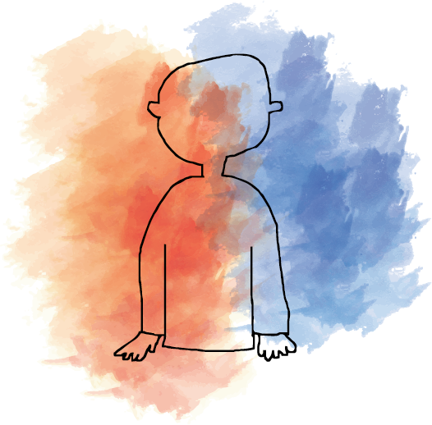
Trauma-Based
Self-Concept
Strength-Based
Self-Concept
“I shouldn’t try. I’ll just fail.”
“I don’t belong.”
“I’m not worth anything.”
“Somebody’s gonna hurt me any moment now.”
“I have no future.”
“I’m constantly in pain.”
“Adults are out to get me.”
“I’m unloveable.”
“I have no talents.”
“I’m ugly.”
“I’m abnormal.”
“I’m broken beyond repair.”
“I can’t do it.”
“My math teacher noticed this drawing I was doing. Is she just being nice or am I good at art?”
Take a solid five minutes to do nothing but observe students and make a note of the positive things you observe: something they do, something they say, a way they act, or something they wear. Then find one minute in the hallway, or in a one-on-one during class, to say to one student, “I liked the way you…”

